Day- 06 29-May 2025

Mohammed Arsalain

Employee ID: 109890529

Email Id: mobarsal@amazon.com

Task 1:

RegEX Symbols in linux

List them down with description

Regular expressions, or regex for short, are powerful tools used in Linux for pattern matching in text. They define search patterns that can be used with various commands like grep, sed, and awk to find, replace, or manipulate text within files or streams

. (dot) matches any single chsracter

(* ) Matches zero or more of the previous character

? makes preceding character optional (0 or 1 time)

^ anchors the match at the start of a line

$ anchors the match at the end of a line

[] matches any one character inside the brackets

[^] matches any one character except those in brackets

{n} matches exactly n occurences of the previous character

{n.} matches n or more times

{n.m} matches between n and m times

() groups expressions

` acts like or

\ escpaes a special character

Task 2:

What are the imp features of Linux os ?

1 linux is free and open source ( we can view , modify and distribute the code)

2) Multi tasking

Linux can run on multiple programs at the same time

3) multiuser capabilities

More than one user can log in and use the system at the same time

4)Stability and reliability

Linux is known for running for years without crashing

Commonly used for servers and critical systems

5) security

Linux is considered as very secure

Features includes :

File permissions : (chmod , chown)

User privilages ( normal vs root)

Firewall

SELinux and AppArmor

6) portability

7) Shell / command line interface

8 file system support

9) package management

10) community support

Programming friendly

Lstring networking

Task 3:

WHAT IS Kernal and can you explain its functions

Kernal is Core part of the linux operating system

Is acts as a bridge between hardware and software

Think it as a brain of the OS that controls everything in your computer

It manages system resources like CPU, memory, and devices, enabling efficient and secure multitasking. The kernel's main functions include process and memory management

Main faunctions are :

Process management

Memory management

File system management

Device management

System cells interface

Security and access control

Task 4:

What is BASH? Full form with explanation.

Bash – Bourne again Shell

It is a interpreter and command line shell and scripting

Language used widely in Linux and Mac like OS

bash allows users to interact with the operating system by entering commands.

Task 5

What is the difference between window and linux

Linux is a Open source operating system and unix Like operating system shares similar features and developed based on Unix OS , many different distribution systems available for free of cost , Linux is used in a wide range of environments, including servers, desktops, smartphones, embedded systems, and even appliances.

Unix is closed source operating system , Unix has been popular used in server environments, workstations, and mainframes.

Task 6

Define the basic components of Linux

The core components of a Linux operating system include the kernel, system libraries, and system utilities

A LINUX Dystem is divided into three parts

1. Hradware
2. Kinux kernel
3. User Space

Task 7:

Is it legal to edit Kernal?

Yes, it is legal to edit a kernel, specifically the Linux kernel, as it is released under the GNU General Public License (GPL). The GPL allows users to modify and distribute the code under the same licensing terms.

how many of you have gone through techadamy Linux plz raise ur hand--- Done

Task 8

Can you explain LILO

LILO (Linux Loader) is a bootloader used in Linux-based systems. It manages the boot process, allowing users to choose which operating system to load when the computer starts. Essentially, LILO acts as the first program that runs when the computer is turned on, presenting a menu (or a default selection) to the user so they can choose which operating system to start. It loads the kernel and other supporting files into memory, transferring control to the operating system.

• LILO is known for its simplicity and reliability. It's also capable of booting older systems with limited capabilities.

Task 9

What What is shell? How many shells are there and what are they ? can you explain.shell

A "shell" is a program that provides a user interface to an operating system (OS), acting as an interpreter for commands and allowing users to interact with the OS. There are several types of shells, each with its own set of commands and features, primarily categorized as command-line shells and graphical shells. There are numerous shell options, each with its own features and strengths. Popular examples include Bash, Zsh, and Csh

Task 10

What is SWAP

In Linux, swap space acts as an extension of RAM, providing additional virtual memory when physical memory is full. It's a portion of the hard drive or a dedicated file that the system uses to temporarily store inactive processes or data when RAM is exhausted.

Task 11:

What is Mount ? how do you mount and unmount file system in Linux?

The mount command mounts a storage device or filesystem, making it accessible and attaching it to an existing directory structure.

The umount command "unmounts" a mounted filesystem, informing the system to complete any pending read or write operations, and safely detaching it.

Task 12

What is CHmod

The chmod command is used to change the access permissions of files and directories in Unix and Linux systems. It allows you to control who can read, write, and execute files, and who can search directories.

Task 13

Can you add a new user account? Crate a new user in different ways and paste ss

To add a new user in Linux, you can use the adduser or useradd command, followed by the desired username. Once created, the user account needs a password set using the passwd command

Eg : sudo adduser username

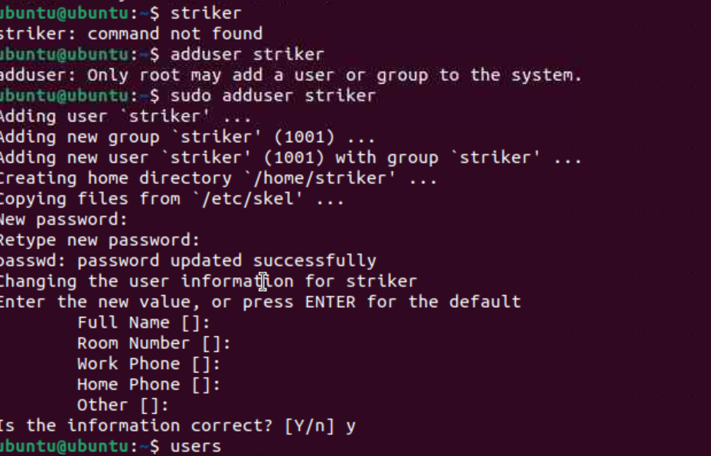

Task 14:

Can you change the password of a user?

Yes, you can change the password of a user in Linux. You can use the passwd command through the terminal to change either your own password or the password of other users (with appropriate privileges)

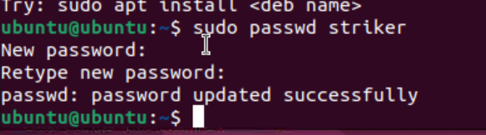

Task 15

What is diff between Process and Thread?

A process is a program in execution, while a thread is a unit of execution within a process. Processes are independent, with their own memory space, while threads within the same process share memory and resources

A Linux process is an instance of a running program in the Linux operating system. It represents an independent unit of execution that operates within its own memory space and has its own set of system resources. Each process is assigned a unique Process ID (PID) that distinguishes it from other processes.

A Linux thread is a lightweight unit of execution within a process that can operate independently. It allows for concurrent execution of tasks, enabling parallel processing and efficient resource utilization. Threads share the same memory space and resources with other threads in the process, making data sharing and communication between threads seamless.

Task 16

Doc 14 Linux Grep commands .. plz work on it..

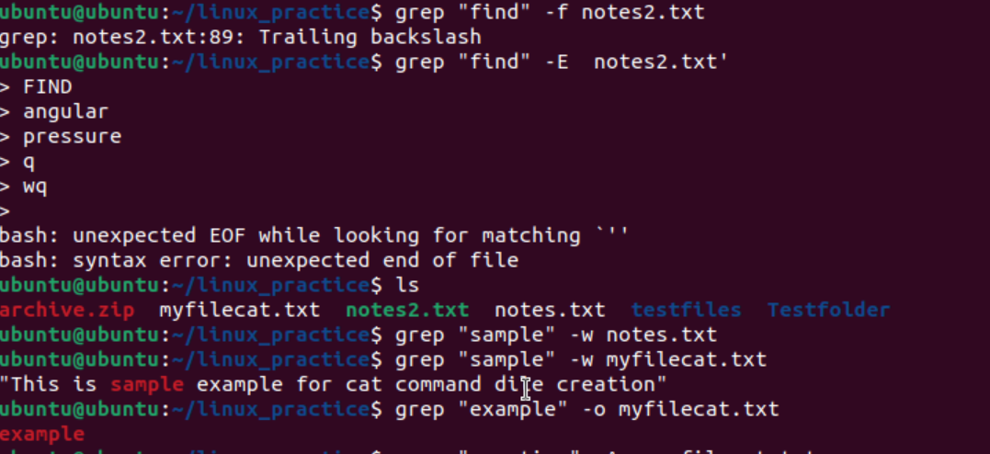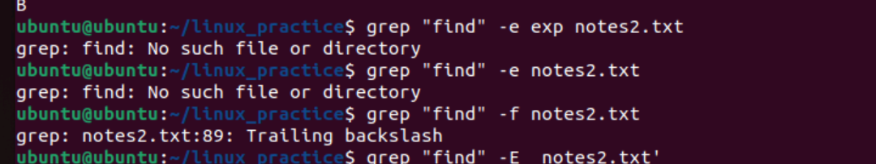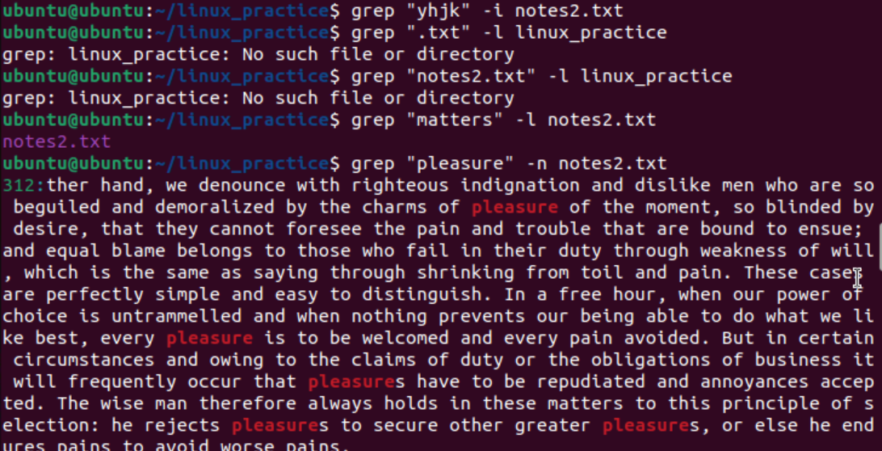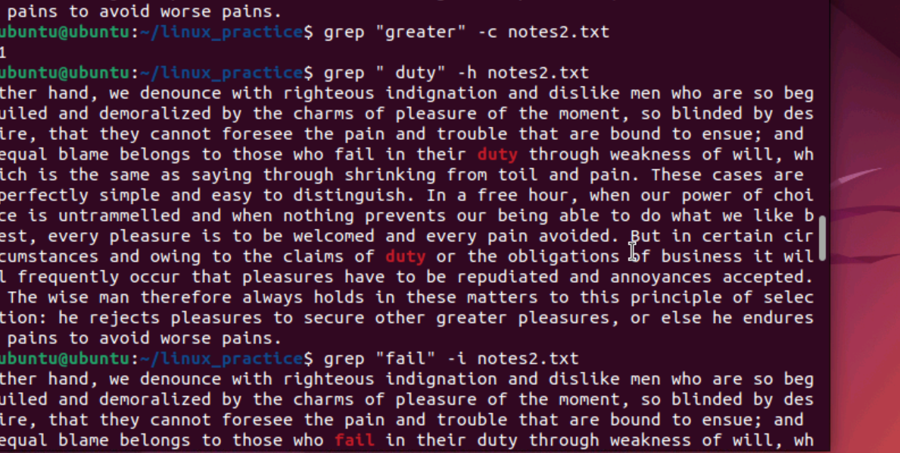

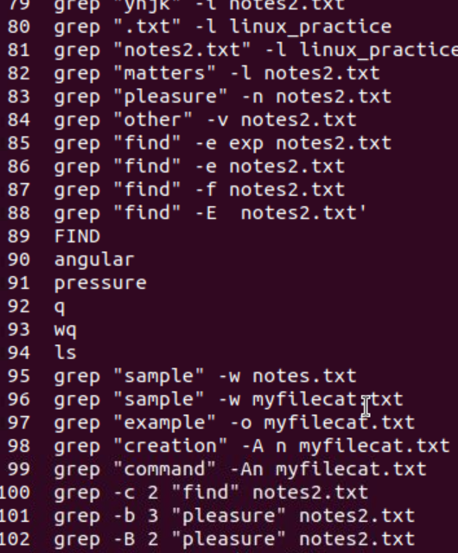

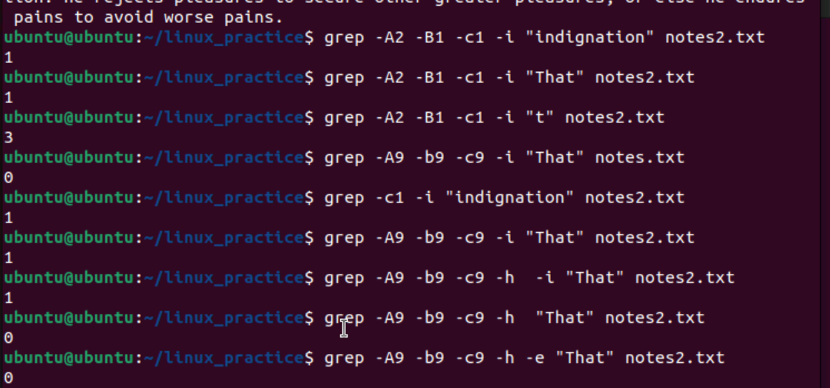

Task 17 → for AWK commands

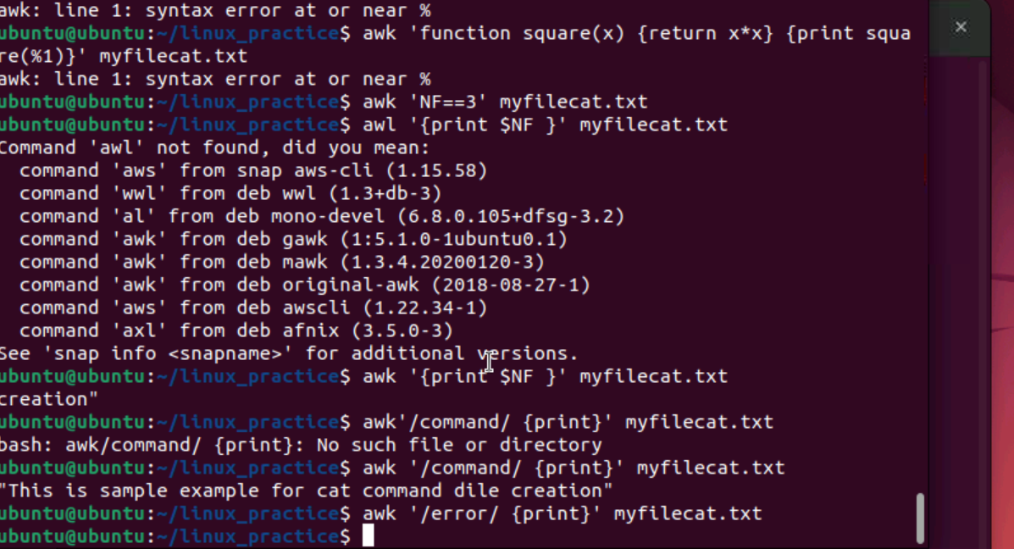

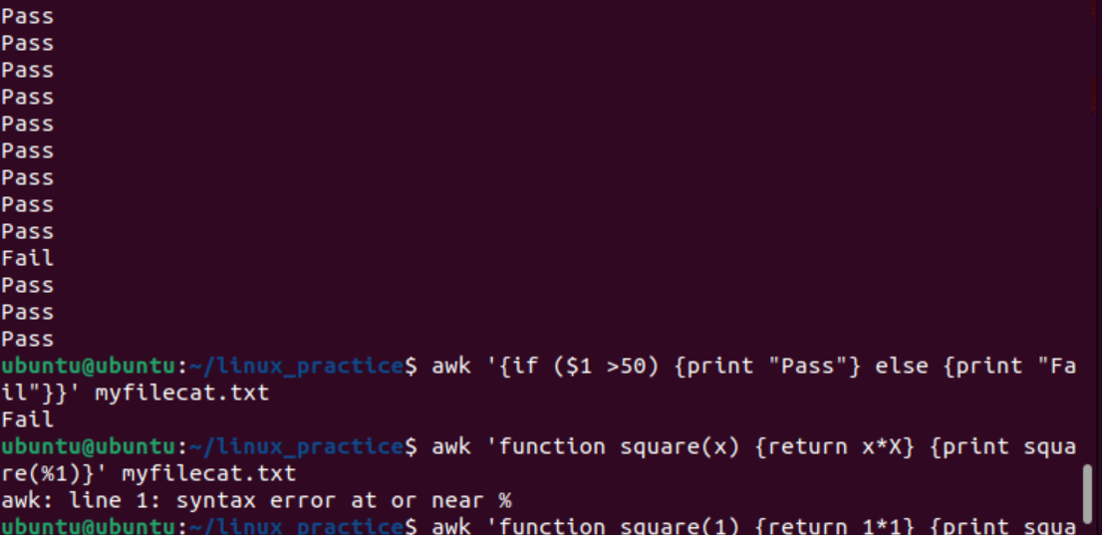

Task 18

How to check file access permission in Linux?

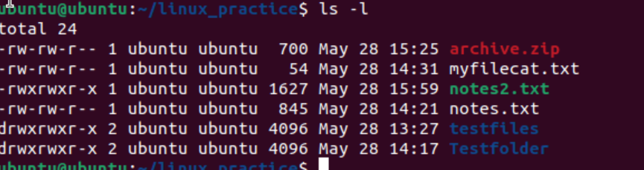

Task 19

What are the default permissions for a new file ?

Default permisiions is rw-r –r—

Owner   → rw- can read and write

Group → r—read only

All and others → r—read only

Task 20:

What is the command to change the permisssion to read only for the owner, group and all other users

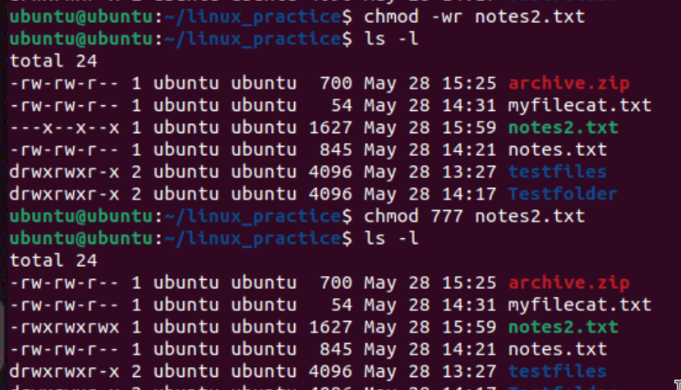

Task 21:

Can you change the file permissions to match the following:

* owner: Read and Write
* group: Read

other: no permissions (None)

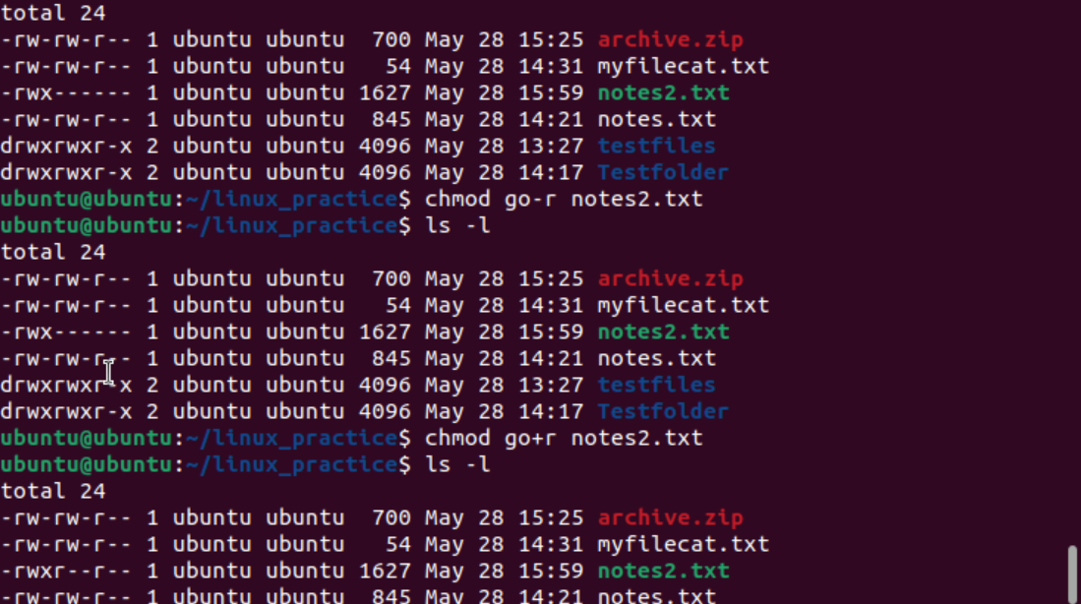

Task 22:

What was the command for changing teh file permissions to -rw-r-----?

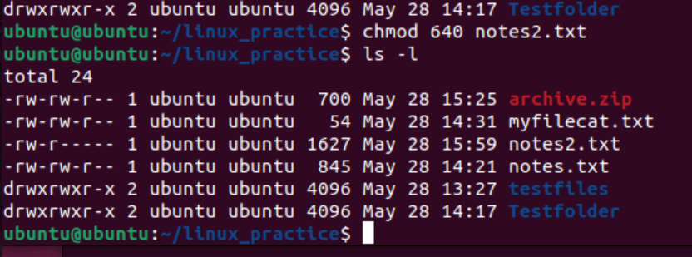

Task 23:

Change chmod.exercises permissions to -rwxr-x--x

Change the file permissions to match the following:

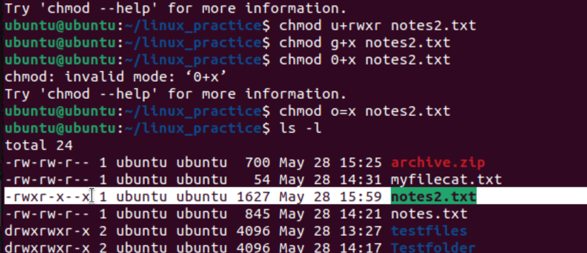

Task 24:

What was the command for changing the file permissions to -rwxr-x--x

Hint : use chmod 751 filename

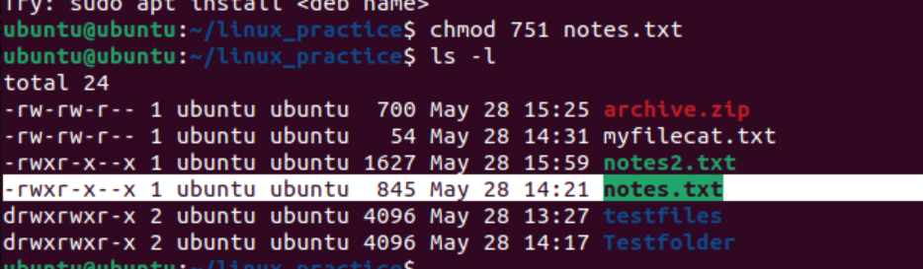

Task 25:

Guys what will this command do?

chown -c master file1.txt

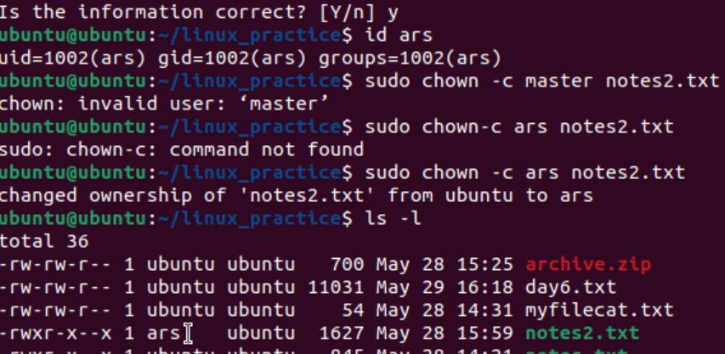

Task 26

Can you define what is  a process

What is command to check foreground process and background process

A **process** is simply the instance of a running program.

Processes can run in the foreground and background. **Foreground** processes is any command that you enter in the prompt, whereafter you have to wait for its completion before being able to enter a new command. Up till now you've only been executing commands as foreground processes. Unlike foreground processes, when a **background** process has been executed you don't have to wait for its completion before being able to issue a new command. Any command can be run as a background process by typing a space and &' after the command,

Task 28

Can you list all the running processes?

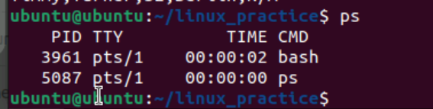

Task 29

What will ps -f command do ? plz try n check .. ss required.

Is hsows detailed information like :

UID, PIDM PPID , CPU , STIME,TTY , TIME CMD etc..

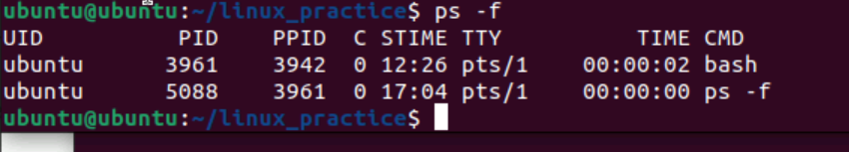

Task 30:

Can you createa  a variable name with your name in it

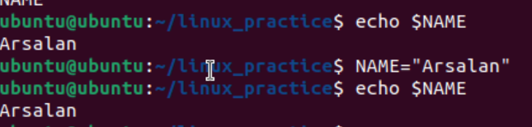

Task 31

Can you make the above name variable read only..

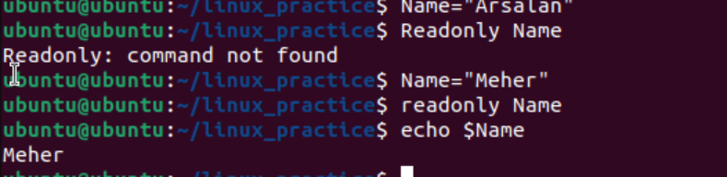

Task 32

Now will unset or delete the variables

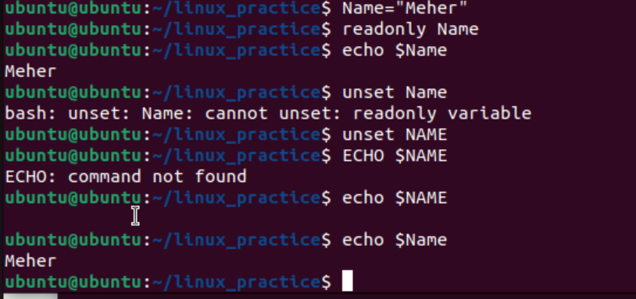

Task 33

CAn u try to add a list of your friends names in an array and try to printout

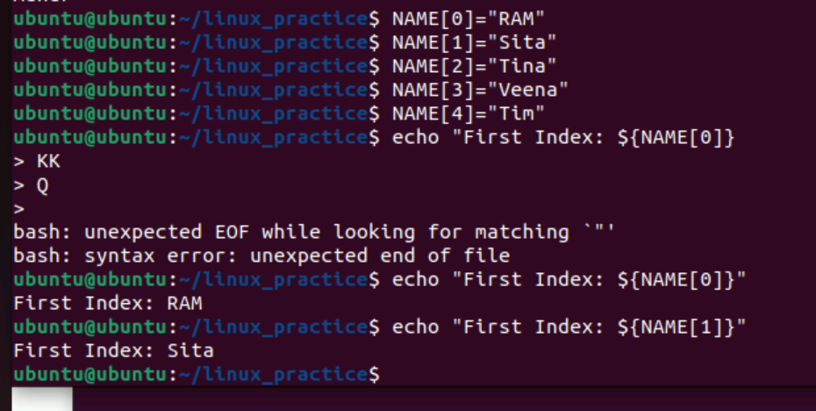

Task 34

Can you print all the list at once in an array.. Try the below cmds and check

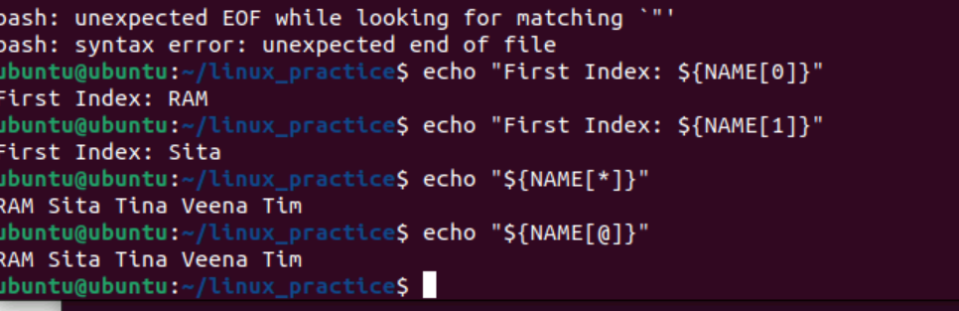

Opetrators 👍

* Arithmetic Operators
* Relational Operators
* Boolean Operators
* String Operators
* File Test Operators

If else

if...fi statement

if...else...fi statement

if...elif...else...fi statement

case...esac statement

The while loop

The for loop

The until loop

The select loop

Plz have an idea about the above

Read n Know that

Variable Types

When a shell is running, three main types of variables are present −

Task 35:

Plz let me know whats the output of the below snippet:

a=0

while [ "$a" -lt 10 ]    # this is loop1

do

   b="$a"

   while [ "$b" -ge 0 ]  # this is loop2

   do

      echo -n "$b "

      b=`expr $b - 1`

   done

   echo

   a=`expr $a + 1`

Done

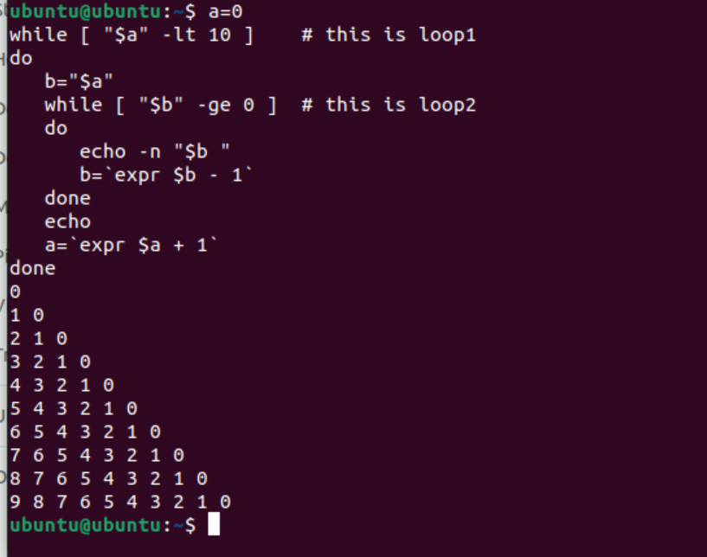

-------------------------------------------------------------------------------------------------------------

Local Variables − A local variable is a variable that is present within the current instance of the shell. It is not available to programs that are started by the shell. They are set at the command prompt.

Environment Variables − An environment variable is available to any child process of the shell. Some programs need environment variables in order to function correctly. Usually, a shell script defines only those environment variables that are needed by the programs that it runs.

Shell Variables − A shell variable is a special variable that is set by the shell and is required by the shell in order to function correctly. Some of these variables are environment variables whereas others are local variables.

## Stopping Processes

Ending a process can be done in several different ways. Often, from a console-based command, sending a CTRL &plus; C keystroke (the default interrupt character) will exit the command. This works when the process is running in the foreground mode.

If a process is running in the background, you should get its Job ID using the **ps** command. After that, you can use the **kill** command to kill the process as follows −

$ps -f

UID      PID  PPID C STIME    TTY   TIME CMD

amrood   6738 3662 0 10:23:03 pts/6 0:00 first_one

amrood   6739 3662 0 10:22:54 pts/6 0:00 second_one

amrood   3662 3657 0 08:10:53 pts/6 0:00 -ksh

amrood   6892 3662 4 10:51:50 pts/6 0:00 ps -f

$kill 6738

Terminated

Here, the **kill** command terminates the **first_one** process. If a process ignores a regular kill command, you can use **kill -9** followed by the process ID as follows −

$kill -9 6738

Terminated

## Parent and Child Processes

Each unix process has two ID numbers assigned to it: The Process ID (pid) and the Parent process ID (ppid). Each user process in the system has a parent process.

Most of the commands that you run have the shell as their parent. Check the **ps -f** example where this command listed both the process ID and the parent process ID.

## Zombie and Orphan Processes

Normally, when a child process is killed, the parent process is updated via a **SIGCHLD** signal. Then the parent can do some other task or restart a new child as needed. However, sometimes the parent process is killed before its child is killed. In this case, the "parent of all processes," the **init** process, becomes the new PPID (parent process ID). In some cases, these processes are called orphan processes.

When a process is killed, a **ps** listing may still show the process with a **Z** state. This is a zombie or defunct process. The process is dead and not being used. These processes are different from the orphan processes. They have completed execution but still find an entry in the process table.

## Daemon Processes

Daemons are system-related background processes that often run with the permissions of root and services requests from other processes.

A daemon has no controlling terminal. It cannot open **/dev/tty**. If you do a **"ps -ef"** and look at the **tty** field, all daemons will have a **?** for the **tty**.

To be precise, a daemon is a process that runs in the background, usually waiting for something to happen that it is capable of working with. For example, a printer daemon waiting for print commands.

If you have a program that calls for lengthy processing, then its worth to make it a daemon and run it in the background.

## The top Command

The **top** command is a very useful tool for quickly showing processes sorted by various criteria.

It is an interactive diagnostic tool that updates frequently and shows information about physical and virtual memory, CPU usage, load averages, and your busy processes.

Here is the simple syntax to run top command and to see the statistics of CPU utilization by different processes −

$top

## Job ID Versus Process ID

Background and suspended processes are usually manipulated via **job number (job ID)**. This number is different from the process ID and is used because it is shorter.

In addition, a job can consist of multiple processes running in a series or at the same time, in parallel. Using the job ID is easier than tracking individual processes.

—-------------------------------------------------------------------------------

—-------------------------------

Mounting

Fstab

Bash

Man

Tac

Find

Export

Printenv

Zip unzip

Sed

Uniq

Diff

Grep

Cut

Awk

Sort

Split

tr